iMeeting X-Mic-LC/LD

iMeeting X Lift-type array Chairman/ Delegate unit
(With 23-array microphones)

Datasheet V2.0

Lift type: With 23-array microphones

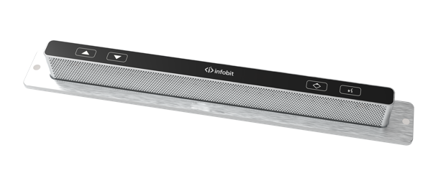 | 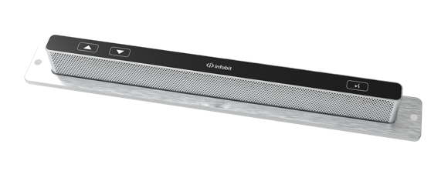
iMeeting X-Mic-LC (Chairman Unit) | iMeeting X-Mic-LD (Delegate Unit)

FEATURES

- Adopt full-digital conference technology, in line with IEC60914 international standard.

- Simple and streamlined desktop design, participants can communicate better without obstruction, and provide better visual effects.

- Array microphone touch buttons, built-in 23 large shock gold film array of microphones, microphone electric lift, with video tracking function.

- Built-in digital circuit excitation chip, which is beneficial to ensure the unit voltage, so that all pickups can reach the best working condition.

- Adopt 150° pickup angle, with a wider range of pickup, whether it is sitting or standing, the sound quality can be guaranteed.

- Using touch switch buttons, precise positioning, rapid control, no mechanical buttons, no wear, unlimited life.

- The bottom of the unit is equipped with two large-area thickened sponge pads, which can effectively alleviate the percussion sound of the desktop and avoid the transmission of non-human voices.

- Establish a personal pickup channel and range, no matter it is a forum or a speech, the sound pressure level will not change.

- Hidden adjustable gain knob, the best pickup distance can reach 80-100cm, and the placement of the unit is not limited.

- The system supports a variety of connection methods such as one-line hand-in-hand connection, T-shaped head hand-in-hand connection and ring hand-in-hand connection.

- Adopt DSP/DDOV digital processing and transmission technology to overcome the problem of long-distance transmission attenuation, and the line distance can reach 150 meters.

- The system adopts 6-core DIN shielded cable or CAT6 network cable, which can effectively avoid and prevent the electromagnetic interference of the line and ensure that the data will never be lost.

- The unit is a passive device, and the conference host provides 24V power supply, low power consumption design, and a single channel can connect 25 conference units.

- Adopt digital strong anti-interference technology to ensure that the equipment in the venue is not interfered by mobile phones, Bluetooth, radio, WiFi and other signals.

- With the camera, the camera can be automatically tracked after being preset by the conference host, control keyboard or computer PC software.

- The system has a first-in-first-out working mode and supports camera tracking function, and the number of speakers can be set from 1 to 6.

- Adopt automatic lifting design, aluminum alloy body, beautiful and delicate through anodizing and coloring process.

TECHNICAL SPEC

Microphone Type | Array
Frequency response | 40HZ～20KHZ
Signal-to-noise ratio (SNR) | > 90dB
Dynamic range | 96dB
Total Harmonic Distortion | ﹤0.05%
Microphone Sensitivity | -42dB±2
Working voltage | 24V DC±5%
Quiescent current | 21mA±5%
Dynamic current | 43mA±5%
Number of units open | 1/2/3/4/5/6 or all
Equivalent noise | 20dBA (SPL)
Maximum sound pressure level | 125dB (THD﹤3％)
Number of chairpersons | The system can access 100 chairperson units at the same time
Dimensions | 330(L)×38(W)×224(H)mm
Power consumption | ﹤11W
Installation method | Embedded
Color | Black (can be customized)
Net weight | 2.4Kg

