iMeeting X-Mic-VNRC/VNRD

Smart full-digital desktop conference Chairman/ Delegate unit
(Voting, with Nameplate, Round Gooseneck)
Datasheet V2.0

Gooseneck Round Stem: With Voting and Nameplate

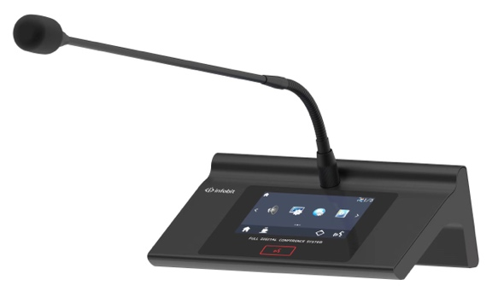 | 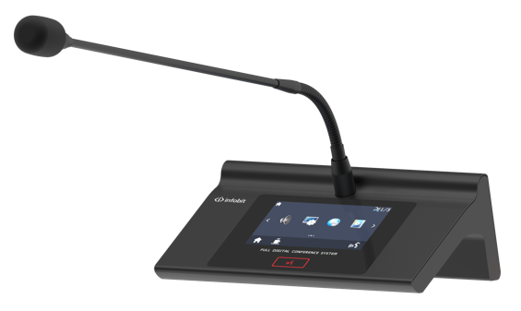
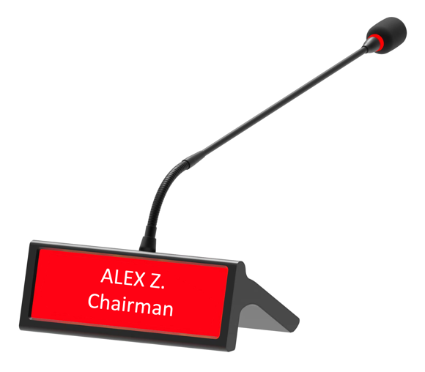 | 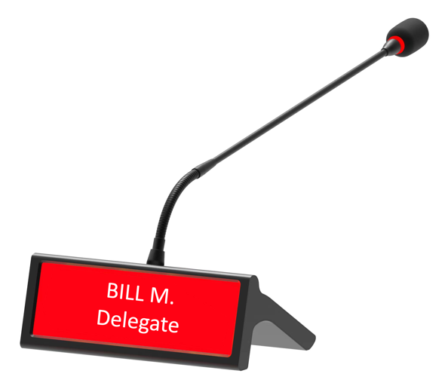
iMeeting X-Mic-VNRC (Chairman Unit) | iMeeting X-Mic-VNRD (Delegate Unit)

FEATURES:

- Desktop design, multi-functional conference unit integrating speech, video tracking, conference service, table card display and touch screen.

- Industrial 300MHz CPU, 512Mb memory, stable system.

- 4.3-inch TFT touch screen, simple and clear operation, friendly man-machine interface, simple and intuitive.

- Support 8-inch high-brightness LCD electronic nameplate display, display participant information, display resolution of 1280 × 320, support single SD card renaming or computer background unified renaming.

- With SD card recording and playback functions, support 128 G flash memory, can record 2K hours of audio content.

- Built-in conference service function, supporting the conference unit to send tea, pen and paper, waiters and other demand notifications.

- Equipped with 2m 6-core DIN cable with shield to effectively avoid and prevent electromagnetic interference of the line.

- The system adopts the ID addressing mode, and the conference controller or conference management software can customize the ID number of the unit to avoid duplication of ID numbers.

- Adopt digital strong anti-interference technology to ensure that the equipment in the venue is not interfered by mobile phones, Bluetooth, radio, WiFi and other signals.

- Support the four working modes of quantity limit, first-in first-out, speech application and voice control start, and the number of speakers can be set from 1 to 6.

- With the camera, the speaker can be automatically tracked, and the picture freezing function is supported.

- Support three-key or five-key voting function, support key sign-in and supplementary sign-in functions, and dynamic display of data.

- Electret super cardioid directional microphone with audio activation ensures pickup distance and sound quality up to 50cm.

- Support 48K audio sampling frequency, frequency response up to 40Hz-20KHz, close to CD sound quality effect.

- Built-in high-pass filter function, easy to cut out the low-frequency components of the sound when needed.

- Equipped with DSP digital audio processing chip, each unit can be independently adjusted for high and low bass.

- With two 3.5 mm headphone ports, it can be used for conference monitoring and recording, and the volume is adjustable.

- With one Micro USB data interface, the equipment can be upgraded and maintained without disassembly.

- It has the function of restoring the factory value, which can initialize the audio adjustment to prevent the sound disorder.

TECHNICAL SPEC

System capacity | Single channel 10 sets, expandable 51200 sets
Display screen | 4.3 "TFT touch screen, 8.8 " LCD display
Microphone type | Cardioid directivity electret
Frequency response | 40Hz~20KHz
Signal-to-noise ratio (SNR) | >90dB
Dynamic range | 96dB
Total harmonic distortion | < 0.05%
Channel separation | 102dB
Microphone sensitivity | -37dB±2dB
Operating voltage | 24V DC±5%
Operating current | 100mA ±5%
Unit power consumption | 3W
Equivalent noise | 20dBA (SPL)
Maximum sound pressure level | 125dB (THD<3%)
Size | 152×98×62mm
Weight | 1.15kg

