iMeeting X-Mic-VRC/VRD

Smart full-digital conference Chairman/ Delegate unit
(Voting, with 3.5-inch screen, Round Gooseneck)

Datasheet V2.0

Gooseneck Round Stem: With voting and screen

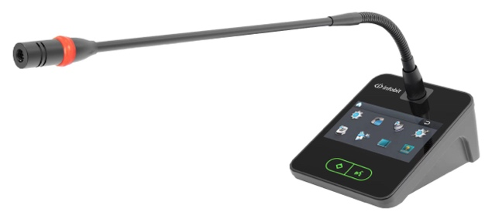 | 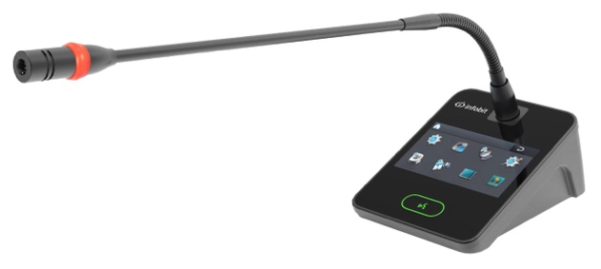
iMeeting X-Mic-VRC (Chairman Unit) | iMeeting X-Mic-VRD (Delegate Unit)

FEATURES:

- Full digital conference technology, simple and strong anti-static desktop function design, in line with ergonomics, very modern sense of science and technology.

- With a 3.5-inch touch screen, it can display speech time, speech timing, perpetual calendar, conference call service and other functions.

- Adopt light touch keys, accurate positioning, rapid control, no mechanical keys, no wear.

- Gooseneck condenser microphone stem, professional large capacitor core, extremely high sensitivity and voice clarity, and with speaking ring red and green two-color indicator.

- Multi-functional conference speech unit integrating speech discussion, video tracking, voting and conference service.

- DSP digital processing and transmission technology is adopted to overcome the problem of long-distance transmission attenuation. The six-core cable distance can reach 250 meters, and the network cable distance can reach 150 meters.

- The chairman has a priority button, which can quickly close the delegate unit. The delegate unit can be set as a VIP unit. The VIP unit is not limited to speak and will not be opened and closed by other delegate units.

- 24V power supply is provided by the conference controller, with low power consumption design, and 20 conference units can be connected in a single way.

- Adopt digital strong anti-interference technology to ensure that the equipment in the venue is not interfered by mobile phones, Bluetooth, radio, WiFi and other signals.

- The camera tracking function is available with the conference controller, which can be preset through the conference controller, control keyboard or PC software.

- The system has first-in first-out, limited mode, speech application and other modes, and the number of speakers can be set from 1 to 6.

- Designed with advanced electrostatic isolation technology to avoid static electricity even in dry environments and regions.

- Live "hot plug" function is available between units, so that the safety of the system is more guaranteed.

- Speech unit equipment adopts non-compressed audio transmission technology, 48K sampling rate, 20Hz-20KHz bandwidth, perfect sound quality; With low delay technology, the output from microphone sound to power amplifier is less than 10ms; Long-distance high-fidelity pickup, with effective pickup distance greater than 50cm.

- The system adopts the ID addressing mode, and the conference management software or the conference controller defines the ID number of the unit to avoid ID number duplication.

TECHNICAL SPEC

Power consumption | 1.8W
System capacity | 15 sets of six-core unit in single channel, which can be expanded to 51200 sets
Display screen | 3.5-inch TFT contact display
Display menu | Chinese and English (customizable)
Frequency response | 20Hz~20KHz
Signal to noise ratio (SNR) | >90dB
Dynamic range | 96dB
Channel separation | 102dB
Total harmonic distortion | < 0.05%
Microphone type | Imported gold film pickup head
Microphone sensitivity | (-42dBV/Pa)
Operating voltage | 24V DC±5％
Operating current | 40mA ±5％
Connection mode | Junction box
Number of units on | 1/2/3/4/5/6
Equivalent noise | 20dBA (SPL)
Maximum sound pressure level | 125dB (THD∠3%)
Mic stem L | 200mm
Unit connection port | 6-core DIN
Net weight | 0.8kg
External dimensions | 127 × 97 × 57mm (excluding the MIC stem)

